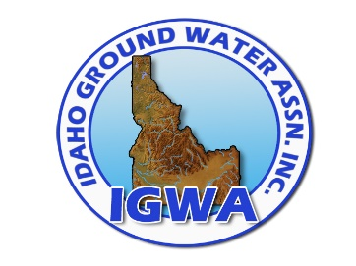
2023 IGWA Virtual Workshop
Friday, March 17, 2023

8:00 – 10:00 AM CAT Engine Maintenance
Andrew Fackler, Western States Caterpillar

10:00 – 11:00 AM CDL Program Changes
Seth Uhlenkott, Safety Compliance Solutions

11:00 – Noon Fundamentals of Dual Tube Flooded Reverse Drilling
Art Steelman, Matrix Drilling Products

Noon – 1:00 PM Break for Lunch

1:05 – 2:05 PM State Damage Prevention Safe Digging
Bill Hale, Division of Building Safety

2:05 – 3:05 PM Idaho Rules & Regulations
Erik Boe, Idaho Department of Water Resources

